21.59: a) , in the direction from and towards 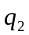.
b) If 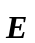 is at 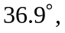 and the torque 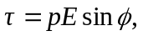 then:
